SENARAI DAN SPESIFIKASI PERALATAN PARA OLAHRAGA 2026

No. | Disiplin sukan | Senarai Peralatan | Gambar | Kuantiti | Harga Seunit  (RM) | Jumlah (RM)
1 | THROWER STANDING | BAR BELL | 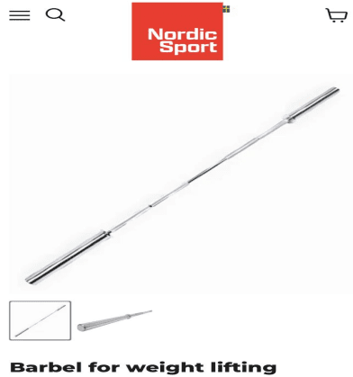 | 20kg - 1 UNIT
2 | THROWER STANDING | DISCUS | 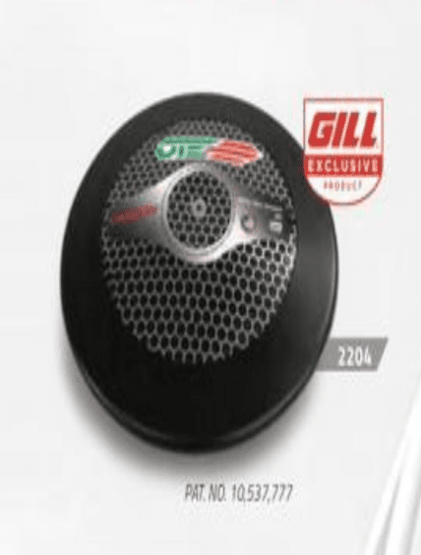 | 1KG- 6 UNIT  2KG - 6 UNIT  CARBON DISCUS
3 | THROWER STANDING | SHOT PUT | 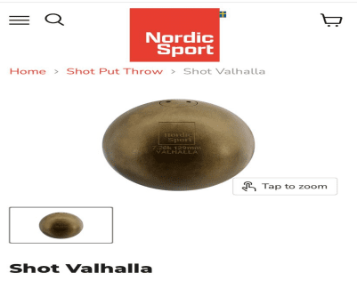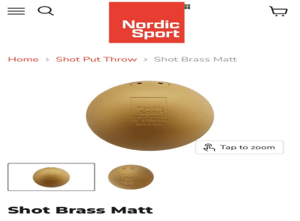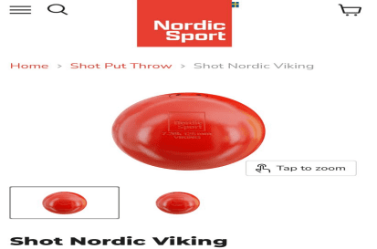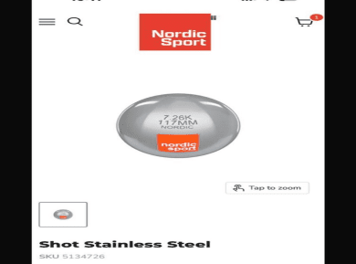 | 3KG- 105  10 UNIT  3.5KG-105MM  10 UNIT  4KG- 105MM  15 UNIT  5KG- 110MM  10 UNIT  6KG-126-128MM  10 UNIT  7.26KG-127-129MM  (17 UNIT)  Valhall- 6 unit  Nordic viking- 6unit  Stainless steel- 5 Unit  8kg-127-129MM  (5 UNIT)
4 | THROWER STANDING | SPORT CHALK | 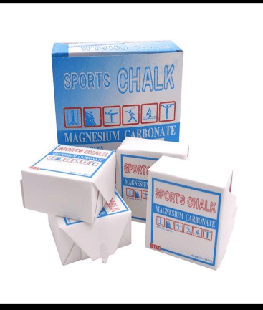 | 10 DOZEN
5 | THROWER STANDING | JAVELIN | 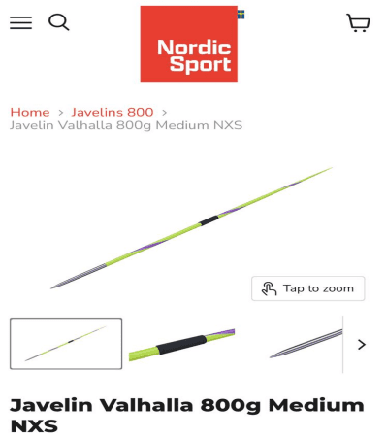 | 600g- 5 UNIT  700g- 5 UNIT  800g- 5 UNIT
6 | THROWER  STANDING | MEASURING TAPE STEEL | 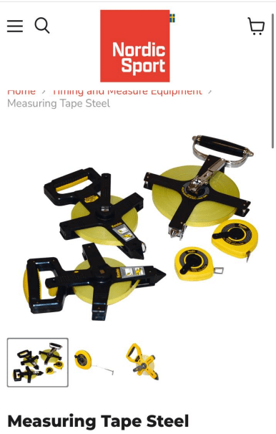 | 30M- 1 UNIT  100M- 1UNIT
7 | THROWER STANDING | WRIST BAND | 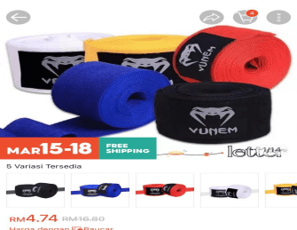 | 15 UNIT
8 | THROWER  STANDING |  | 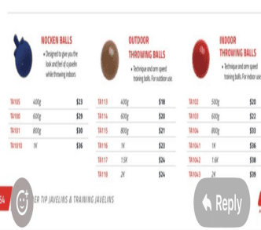 | NOCKEN BALL  400g - 1 UNIT  600g - 1 UNIT  OUTDOOR THROWING BALL  800g- 1 UNIT  1KG- 1 UNIT
9 | THROWER  STANDING | BENCH CHAIR | 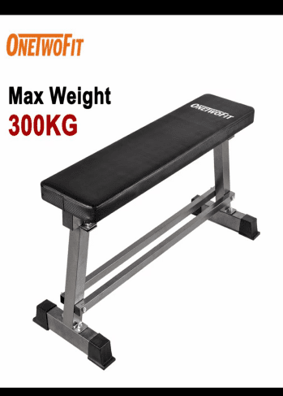 | 1 UNIT  KETAHANAN MELEBIHI 300KG
10 | THROWER  STANDING | MEDICINE BALL | 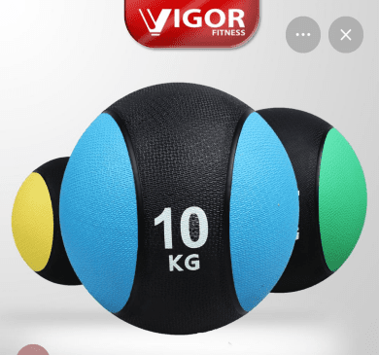 | 3KG - 5 UNIT  4KG - 5 UNIT  5KG - 5 UNIT  6KG - 5 UNIT  8KG - 3 UNIT  10KG - 2 UNIT  12KG - 2 UNIT
11 | THROWER  STANDING | BARBELL COVER PAD | 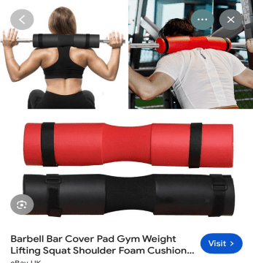 | 3 UNIT
12 | SPRINTER | TIMING GAUGE | 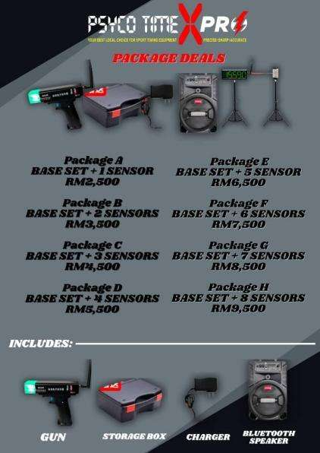 | 8 SENSOR
13 | SPRINTER | STARTING BLOCK  (IAAF STANDARD) | 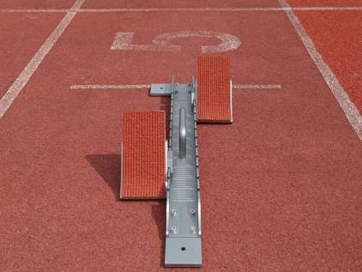 | 6 UNIT
14 | SPRINTER | STOPWATCH  (CASIO HS-70W-1) | 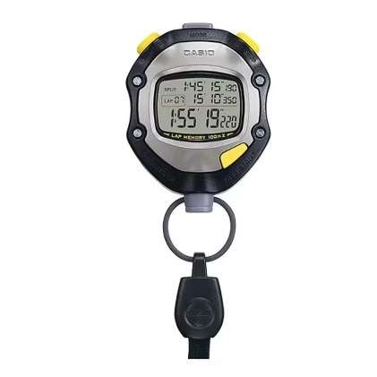 | 2 UNIT
15 | Wheelchair thrower | Discus  Brand : VINEX HIGH SPIN | 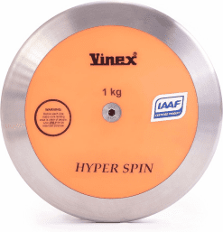 | 1kg - 8 units
16 | Wheelchair thrower | Medicine ball | 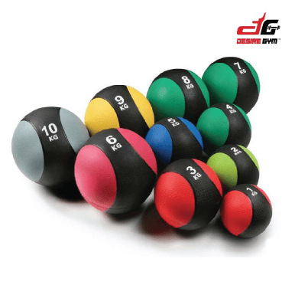 | 2kg - 2 unit  3kg - 2 unit  4kg - 2 unit
17 | Wheelchair thrower | Shotput Rack | 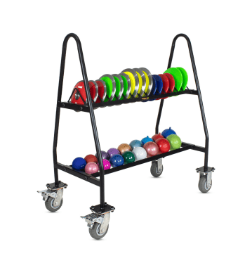 | 1 unit
18 | Wheelchair thrower | Dumbell Rack | 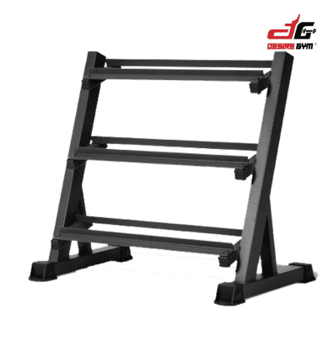 | 1 UNIT
19 | Wheelchair thrower | Olympic Barbell  (Brand: ELEIKO / UESAKA / ZKC) | 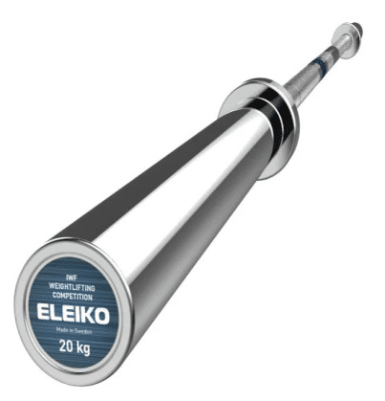 | 20kg - 1 unit
20 | Wheelchair thrower | ADJUSTABLE BENCH  (Brand : LIFE FITNESS) | 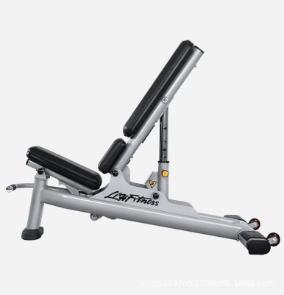 | 1 UNIT
21 | Wheelchair thrower | Roller Foam 3 in 1  Brand : DECATHLON | 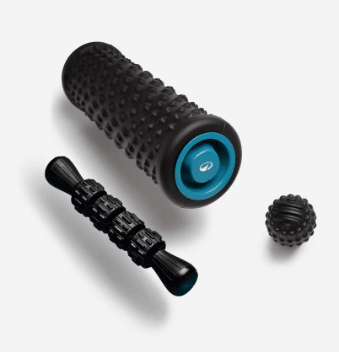 | 5 UNIT
22 | Wheelchair thrower | Exercise Mat  Brand : DECATHLON | 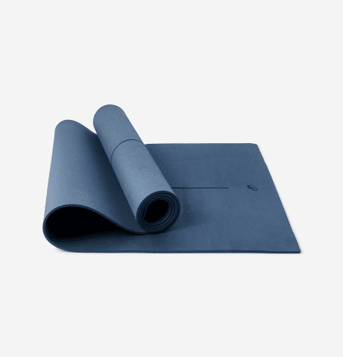 | 5 UNIT
23 | Wheelchair thrower | FIELD MARKER | 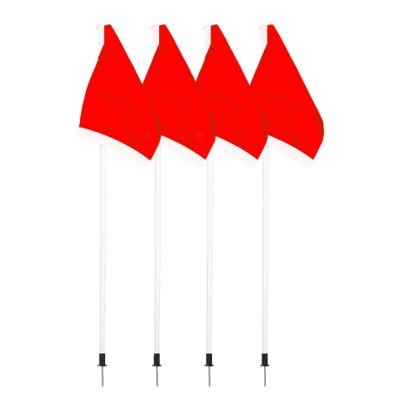 | 5 UNIT
24 | Wheelchair thrower | Chain set for throwing chair | 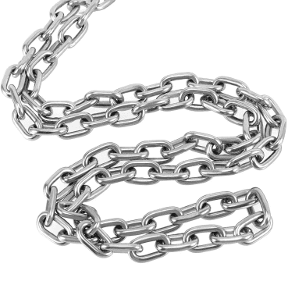  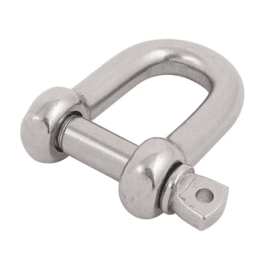  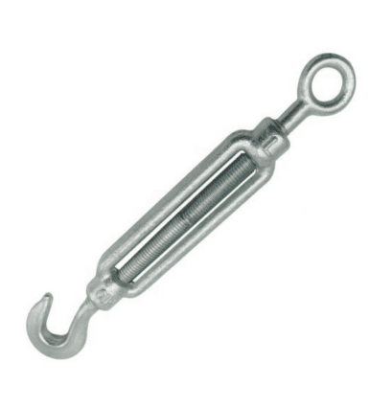 | Chain 2meter  20 unit  D-shackle  20 unit  Turnbuckle hook  20 unit
25 | Wheelchair thrower | Wheelchair tires  Brand :  KENDA KONCEPT / KENDA KONTENDERS | 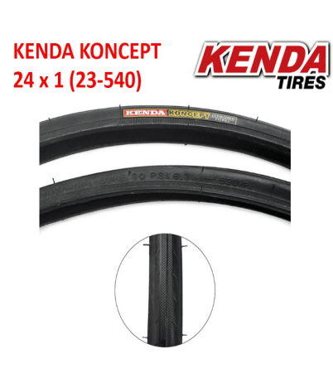  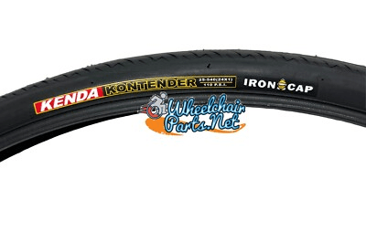 | Size : 24 x 1  30 units  (15 pairs)
26 | Wheelchair thrower | Wheelchair tube  Brand: KENDA | 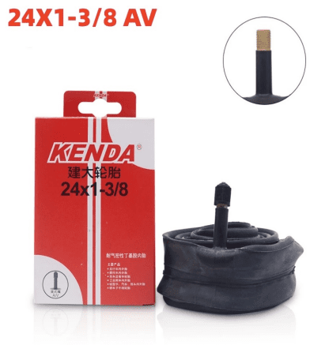 | Size : 24 x 1  AV VALVE  30 unit  (15pairs)
27 | Wheelchair thrower | Wheelchair caster | 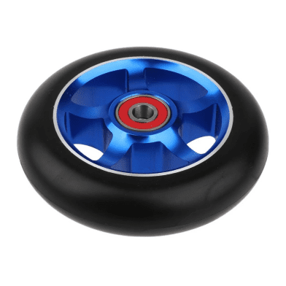 | Size : 5inci x 1  30unit  (15 pairs)
28 | JARAK SEDERHANA | STOP WATCH-  SEIKO | 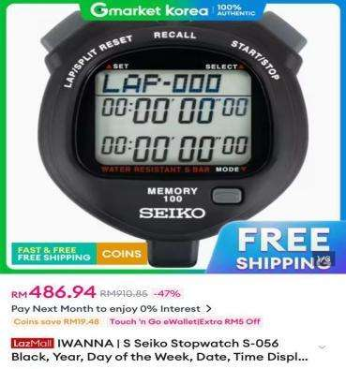 | 2 unit
29 | JARAK SEDERHANA | FOAM ROLLER | 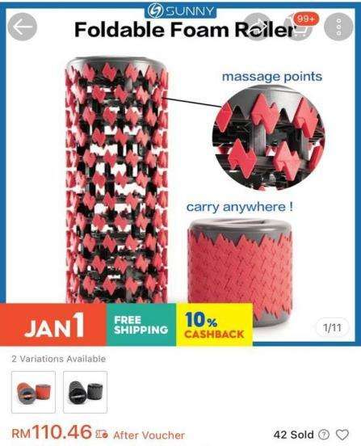 | 6 unit
30 | JARAK SEDERHANA | RESISTANT BAND-  HIP-ADBUCTOR/ ADDUCTOR | 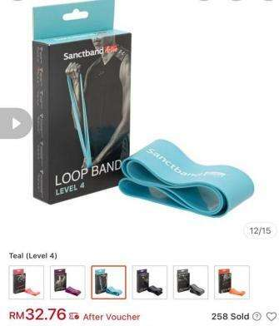 | LEVEL 4  6 unit
31 | JARAK SEDERHANA | RESISTANT BAND-  HIP-ADBUCTOR/ ADDUCTOR | 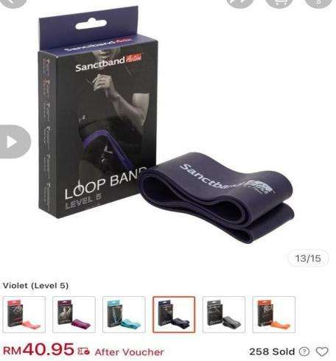 | LEVEL 5  6 unit
JUMLAH KESELURUHAN (RM)

Nota : Mohon dilampirkan sekali dengan katalog dan spesifikasi secara detail.

